Python and Bash
- Grade Checker
Take a score as input and print the grade based on the following:
90+ : "A"
80-89 : "B"
70-79 : "C"
60-69 : "D"
Below 60 : "F"
here we used a basic if else statement to carry out marks and all.
'''
Solution:
marks= int(input("Enter your Marks : "))
if marks >= 90:
print("Grade: A")
elif marks >=80:
print("Grade B")
elif marks >=70:
print("Grade C")
elif marks >=60:
print("Grade D")
else:
print("Grade: F")
Output:
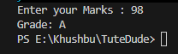
- Student Grades
Create a dictionary where the keys are student names and the values are their grades. Allow the user to:
Add a new student and grade.
Update an existing student’s grade.
Print all student grades.
Used dictionary and basic operations. Using if else:
'''
student = {}
while True:
print("1. Add Student")
print("2. Update Student Grade")
print("3. Display all students")
print("4. Exit")
Choice= input("Enter your choice : ")
if Choice=="1":
name = input("Enter Student name : ")
grade = input("Enter your grade : ")
student[name]= grade
print(" Student added successfully")
elif Choice == "2":
name = input("Enter student name to update: ")
if name in student:
grade = input("Enter new grade: ")
student[name] = grade
print("Grade updated successfully.")
else: print("Student not found.")
elif Choice == "3":
print("\nStudent Grades:")
for name,grade in student.items(): print(name, ":", grade)
elif Choice == "4": print("Program exited.")
break
else: print("Invalid choice.")

Output:
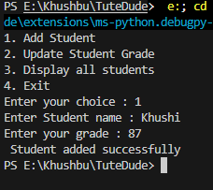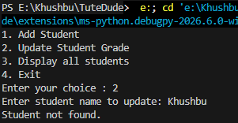

- Write to a File
Write a program to create a text file and write some content to it.
Using file functions like write and open.
Solution :

file = open("sample.txt", "w")
file.write("Hello, this is my first file handling program.")
file.close()
print("Content written successfully.")

- Read from a File
We used open in read mode and file.read to read and print to display.
Solution:
file = open("sample.txt", "r")
content = file.read()
print(content)
file.close()

Output:
